### **iFogSim**

### **Edge Computing Assignment-Simulators**

**Description:**

iFogSim is an **open-source** **simulator** for Edge Computing, Fog Computing, and IoT. It enables the modeling and simulation of fog computing to evaluate resource management and scheduling policies across edge and cloud resources under different scenarios.

### **Download and Installation:**

1. Go to <https://github.com/Cloudslab/iFogSim> and download the simulator in the Zip format.

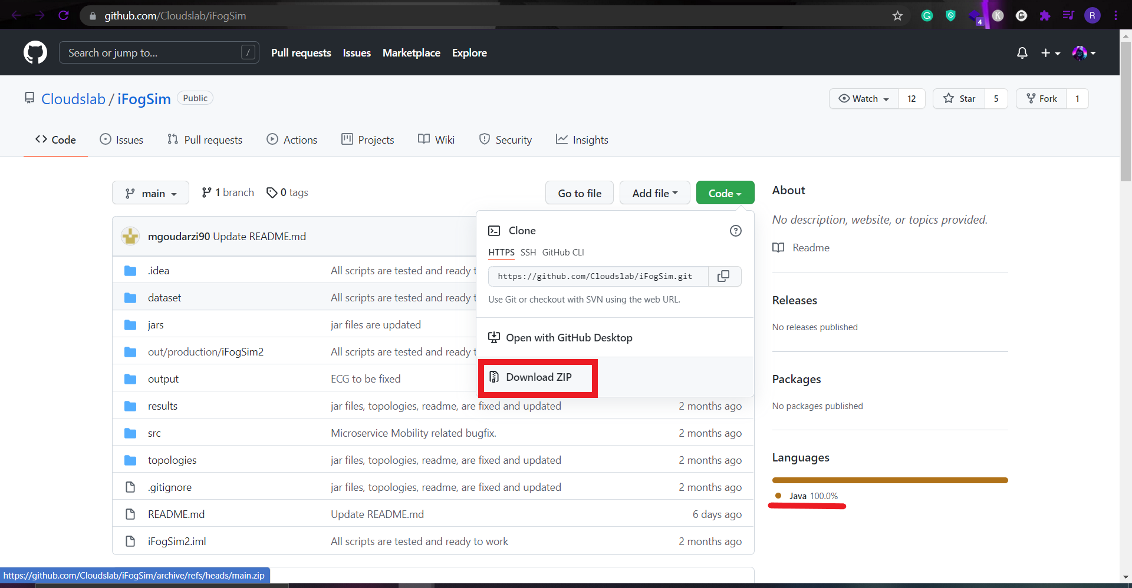

1. After downloading extract the zip folder and **iFogSim-master** will be created.
2. Since the iFogSim completely used Java it can be executed on any Java-based Integrated Development Environment (IDE) eg, Eclipse, Netbeans, etc.
3. In our case, we will be using Eclipse as our IDE to execute iFogSim. Downloading Eclipse is straightforward so we can navigate to <https://www.eclipse.org/downloads/> from there we can download the latest version of Java IDE for Windows or macOS or Linux based on the user operating system.

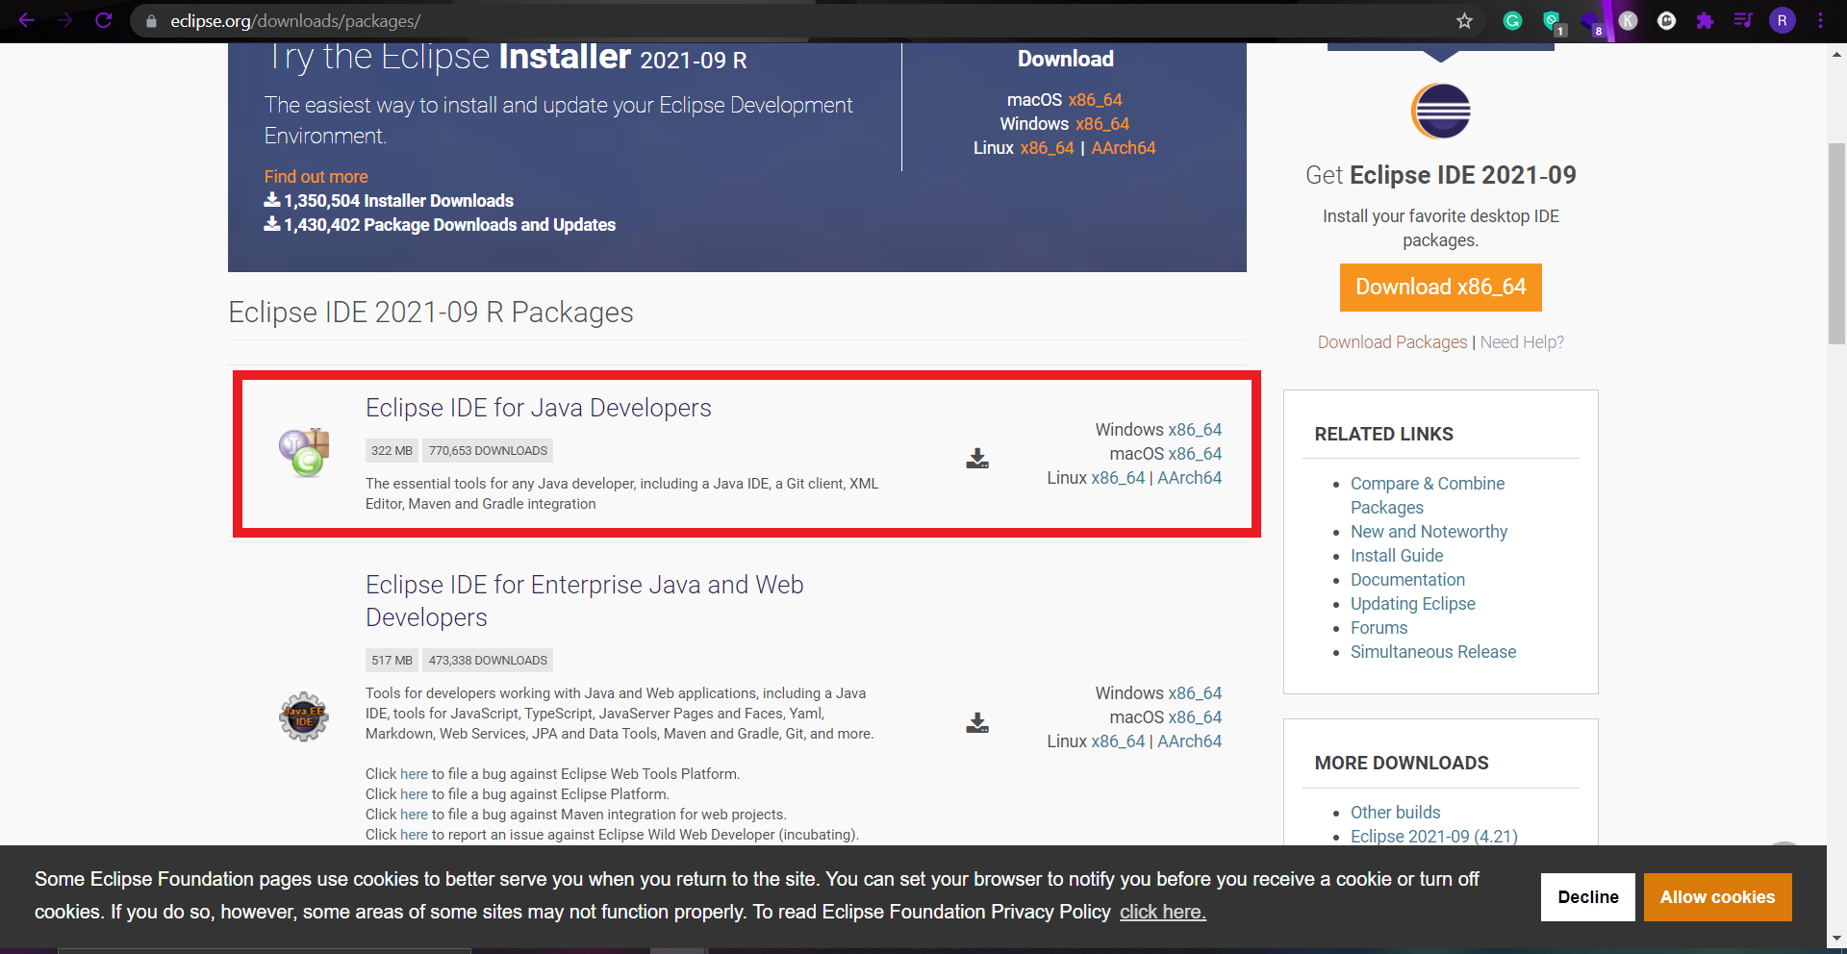

1. After Downloading the Eclipse IDE navigate to the download folder and double click on the eclipse installer executable once it is opened do all the necessary configuration settings and click install and then click launch to open Eclipse IDE.
2. Now we will create a new project in the IDE in order to integrate iFogSim on an Eclipse ID. While creating the new project for “**location**” enter the iFogSim-master’s location which we have downloaded and extracted before.

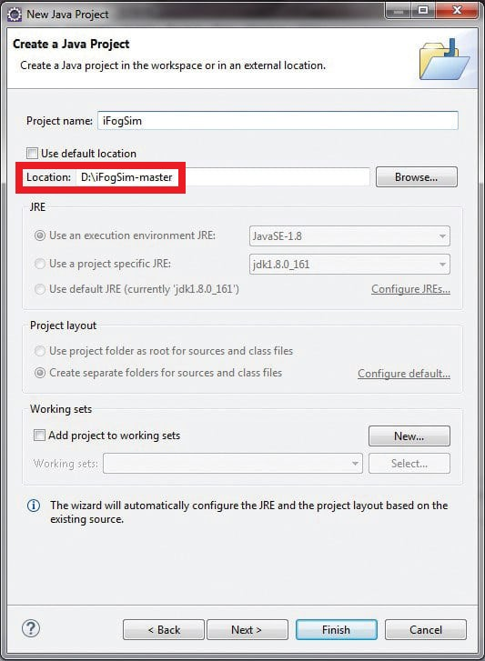

1. Once we finished the setup, the directory structure of iFogSim can be viewed in the Eclipse IDE in project name “**src**”.
2. Now we are all set, we have numerous packages with Java code for different implementations of edge computing, IoT, and fog computing.
3. We can also work with iFogSim in the GUI (Graphical User Interface) mode, For that, we can directly execute the “**FogGui.java”** file in the IDE. Now we can import different edge and cloud components in the simulation working area.
4. In Fog Topology Creator, there is a Graph menu, where there is the option to import the topology. On execution, the output can be viewed in the console of the Eclipse IDE.

### **Applications:**

In iFogSim, there are different scenarios for multiple applications that can be simulated; these include edge computing, software-defined networking (SDN), and its integration with cloud and fog computing.

In the base installation of iFogSim, there are a number of case studies that have been implemented and programmed.

There are fully customizable libraries that can be improved further using new algorithms. The new algorithms can be programmed in the existing libraries of iFogSim so that the performance of the proposed or new algorithm can be analyzed on fog-based networks using iFogSim.

**Rohith S**

**CSE (IoT) - N1**

**RA1811032010058**